Boldmere Tennis Club

Committee Agenda for 10th May 2021 @ 7.30

- Apologies
- Minutes of the last meeting 12th April
- Actions
- Coaching, Juniors & Adults
  - Coaching numbers
  - Junior summer tournament
- Maintenance & Facilities
  - Ongoing care
  - Court surrounds
- Membership
  - Renewals
  - New members.
- Leagues & Tournaments
- Communications (Inc. Website)
  - Facebook / Instagram / Twitter
  - Radio
- Finance & Legal
  - Current financial position
  - RSCC
- Social & Development
  - Open Day planning – June 26th
  - New membership offers.
- Any other business
- Date of the next meeting – 14th June 2021

Actions from last meeting

4.21.1 | Coaching data reporting | GS
4.21.2 | Fixing hosepipe for court cleaning | NA
4.21.3 | Options for lower courts brushing | SM
4.21.4 | Booking of men’s matches on Clubspark | SM
4.21.5 | Liaise with UJ for handover of Social Media access | DG
4.21.6 | Supply photos for website | All
4.21.7 | Routinely add agendas and minutes to website | GS
4.21.8 | Contact surveyor | SH
4.21.9 | Book function room for Presentation Evening | AJ
4.21.10 | Updating of Honours Boards with 2020 winners | SH
4.21.11 | Review contents insurance re Ball Machine | CK
4.21.12 | Run training / orientation sessions on ball machine use | WT
4.21.13 | Can Clubspark bookings identify Ball Machine time | GS
4.21.14 | Request permission from RSCC for notice board and clocks on walls | GS

Coaching Profile

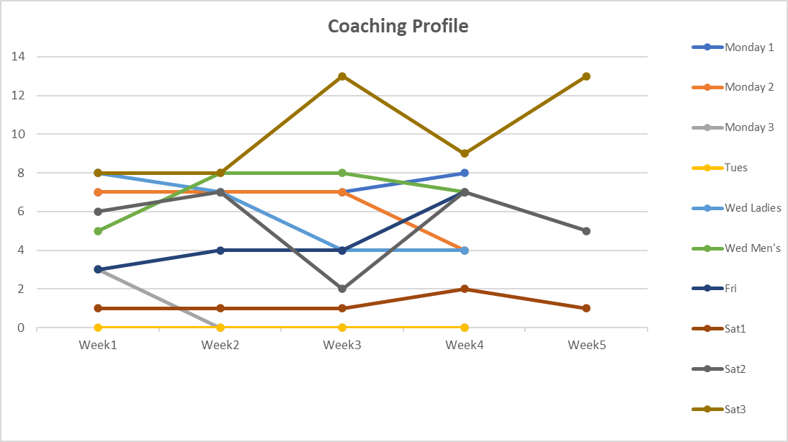

Ball Machine Booking

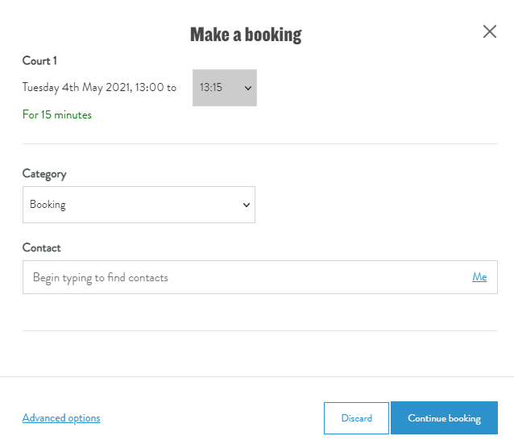 | 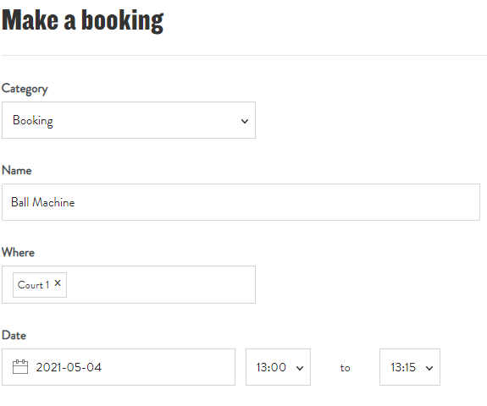
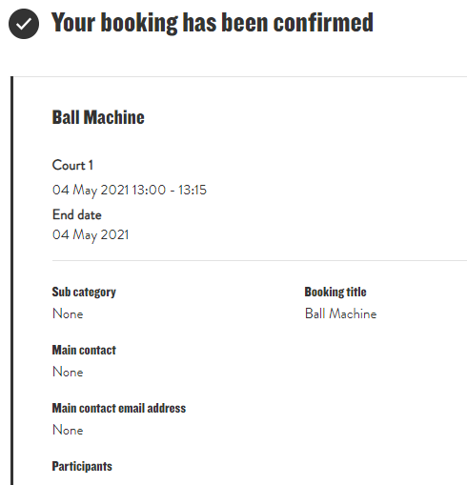 | 